Author: Mudassir Mohammed, Mohammed Faheemuddin

Video credits: Youtube channel Technical Guftgu

**HELM:**

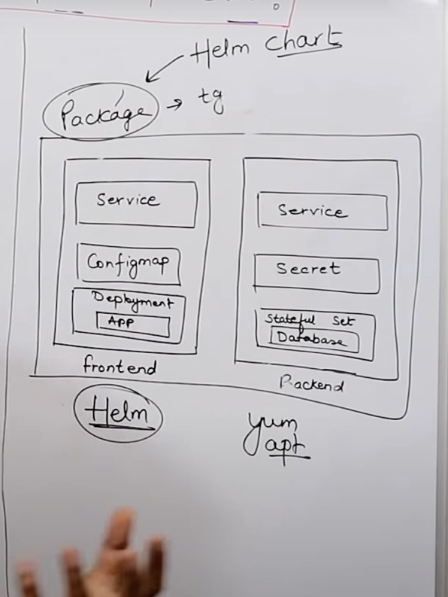

**Some Keywords to Understand HELM:**

**HELM ARCHITECTURE:**

**HELM Commands:**



